** American Baptist Men Of The South**

**ABMOTS**

**Newsletter**

**Recalling, Reclaiming, Renewing Our Manhood in Christ**

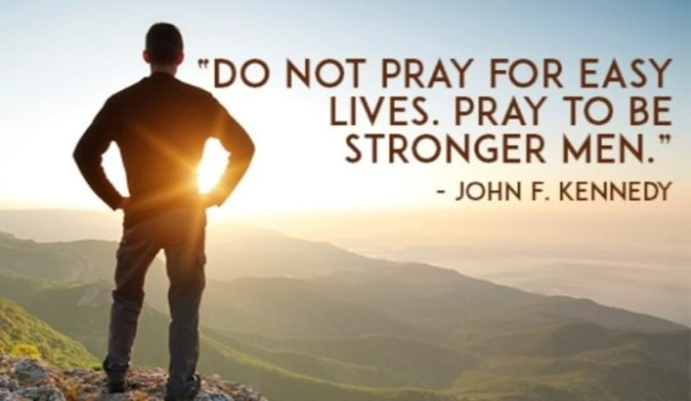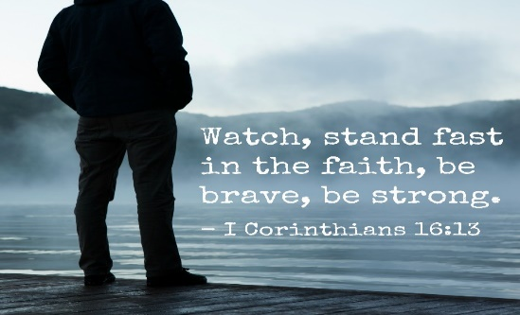

[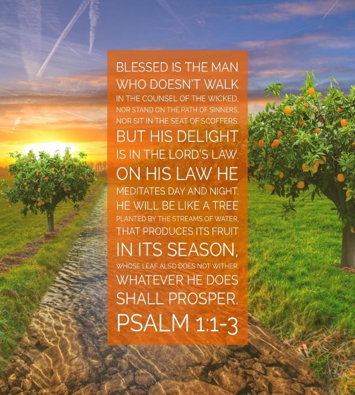](https://bibleversestogo.com/collections/bible-verses-for-men/products/psalm-1-1-3)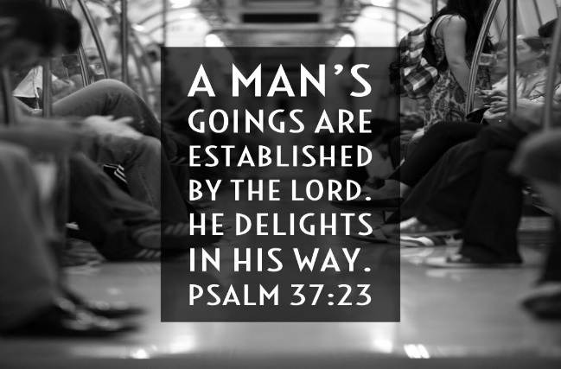

# **ABMOTS Executive Board**

**President Vernon A. Clement**, Ebenezer Baptist Church, Richmond, VA

**Vice President Deacon Andrew Williams**, New Mount Olive Baptist Church,

Fort Lauderdale, FL

**Secretary Open**

**Treasurer Deacon Eugene Alford**, Wheat Street Baptist Church, Atlanta, GA

**Chaplain Dr. Earle D. Clowney**, Friendship Baptist Church, Atlanta, GA

**Parliamentarian Deacon Alvin Coleman**, Mount Zion Baptist Church, Norfolk, VA

**FEATURES**

**Greetings, Men of ABCOTS!**

**I want to officially introduce myself. I am Vernon Adderson Clement, the new President of American Baptist Men of the South (ABMOTS).**

**I am married to Kimberly, with one grown child – Kenneth. I am currently employed by City of Richmond with the Department of Public Utilities in Construction Management and Inspections. I attend the Historic Ebenezer Baptist Church in Richmond, Virginia. Reverend James E. Leary, Jr., D. Div, is our interim Senior Pastor. Currently at Ebenezer, I serve or perform the following: Senior Male Usher Board; a teacher for the Senior Male Church School Class; Superintendent for Church School; bus/van driver. I am on the Youth Work Committee (Team) and the Christian Education Ministry. I am the immediate past President of ABCOTS Area II Men’s Ministry. In the community, I have worked with the Big Brothers Big Sisters (BBBS), Salvation Army Boys & Girls Club – East End, American Red Cross of Richmond & Vicinity (ARC), Special Olympics of VA, and PTA. I have served or am currently serving on the following community boards with positions: BBBS – Chair of Community Relations; Salvation Army Boys & Girls; ARC – Chair of Disaster Services and Human Relations; City of Richmond Police Community Relations Board; City of Richmond PTA Council – Organizer and President; Richmond District PTA – Director; VA PTA State Board – Committee Chair. I am a member of Alpha Phi Alpha Fraternity, Inc. I have held the following positions of leadership locally, regionally and nationally with my fraternity: chapter president, state 1st VP, state and regional associate/director of conventions, regional and national chair of reclamation and retention. I just wanted to give an overview of myself so everyone who does not know me will have a good glimpse of who I am.**

**Vernon A. Clement**

**Purpose of ABMOTS Newsletter**

This newsletter is here to serve **A**merican **B**aptist **M**en **o**f **t**he **S**outh **(ABMOTS)!** If you or your men’s ministry has something to share, this will be the vehicle for you to share it. I am hopeful our newsletter will inform, encourage, and inspire men throughout our region to grow stronger in our faith, step up and into more leadership roles within our churches and communities. I hope this newsletter will help us share good practices around the region and help us implement as well. Finally, I hope this newsletter will become a vehicle where we, men, can talk about what is affecting us personally and spiritually. I am eagerly looking forward to the growth and development this newsletter offers.

**Type of and Submission of Articles**

All articles highlighting your or area men’s ministry’s activities inside and outside of the church are welcome and solicited. When you are ready to submit your article, please check spelling, accuracy of your facts, and confirm any/all quoted or reference sources. Pictures are welcome as well. Please check with individual(s) or organization(s) to get permission before submitting any pictures. Please submit all articles and pictures via email to: [vernonaclement@gmail.com](mailto:vernonaclement@gmail.com).

**Highlights from ABCOTS 49th Annual Session, Baltimore, MD**

Here is the report of American Baptist Men of the South meetings chaired by our immediate past president, Deacon Andrew Ladd – Friendship Missionary Baptist Church in Charlotte, NC. The minutes were written by our current chaplain, Dr. Earle D. Clowney – Friendship Missionary Baptist Church in Atlanta, GA.



Please read the attached letter from the Marian House showing their appreciation for ABMOTS support. Thanks to our Immediate Past President, Deacon Andrew Ladd, for arranging their presentation. We presented them a check for $500.00.



New ABCOTS officers were elected in Baltimore. Reverend Dr. Arrold Martin, First Baptist Church Capitol Hill, Nashville, TN, is our new president.  Dr. Betty Long, First Baptist Church, Hampton, VA, is our new 1st Vice President. Rev. Dr. Wayne G. Thompson, First Baptist Institutional Church, St. Petersburg, FL, is our new 2nd Vice President.

**Highlights from Around the Region**

Deacon Alvin Coleman, Mount Zion Baptist Church in Norfolk, VA, attended the ABC-USA Biennial Mission Summit in Virginia Beach, VA, 21-23 June 2019 – Summit by the Sea. Attached are his thoughts and views.



***First Baptist Church of Manassas, Virginia***

We had two big celebrations in the month of June for the men of First Baptist Church of Manassas, VA. The first occurred on June 15th. The Women's Ministry held the annual Father's Day breakfast. The breakfast, video of Fathers, gifts and speaker were outstanding. FBC of Manassas celebrated Men's Day and Father's Day on June 16th.  Pastor Savage gave an inspired message called, "The Joshua Generation". It was an awesome celebration and the men genuinely felt appreciated.

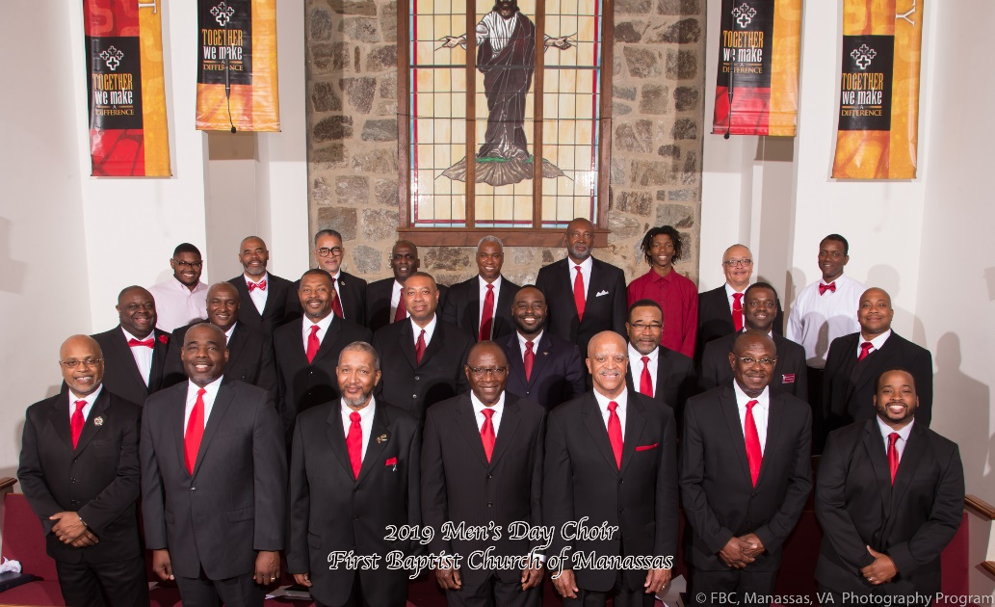

Respectfully,

Tyno Carter

**FYI:**

First Baptist Church of Manassas has a limited number of tickets to hear three-time Superbowl coach, Joe Gibbs speak in Bristow, VA, on Oct 2nd at 7A.M.! The seats are primarily for men that are unsaved, however, unsaved women can attend too. If you would like more information, please contact Brother Carter, [tyno@mail.com](mailto:tyno@mail.com).

***Friendship Baptist Church of Atlanta, Georgia***

Greetings,

The Friendship Baptist Church Men's Ministry in Atlanta, Georgia is pleased to share with you the latest updates of its Men's Ministry in action.

Peace and Blessings,

**Leslie George**

Director of Media and Marketing Communications

 

(Note: Due to technical difficulty unable to share photos sent)

**News from American Baptist Men – USA**

***ABMen USA receive***

***New Shower Trailers***

**By: Bill Morningstar – President**

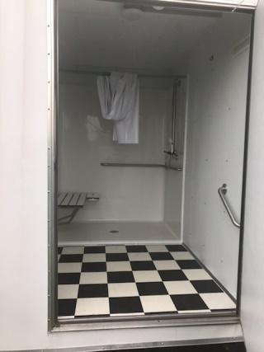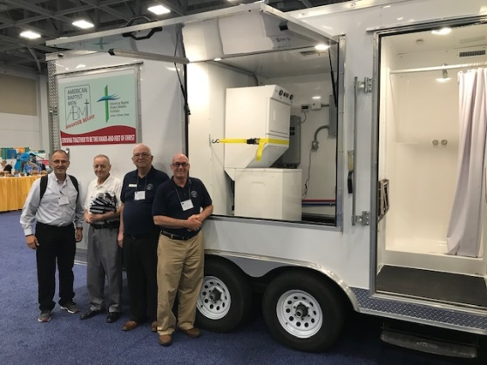The ministry of American Baptist Men USA through a Grant from One Great Hour of Sharing has acquired two new Shower Trailers for its national Disaster Relief Ministries. Historically, Disaster Relief and Work Party ministry teams have had challenges in providing shower and laundry facilities for volunteers in some areas of our ministry work such as that following Hurricane Katrina or Harvey. Future recovery response efforts can now be self-supporting as each trailer is outfitted with multiple shower stalls and a washer and dryer.

The trailers are air-conditioned and quickly operational having its water supply provided through a standard 5/8” garden hose into a self-contained, propane-fueled water heating system with gray water disposed of through a sump pump system directly out of the unit as used.

In addition to supporting disaster recovery teams, these facilities can also be made available to affected communities who are unable to access showers and laundry themselves due to disaster circumstances.

When not deployed the trailers will be maintained at two locations: one to be located at the American Baptist Churches of the Central Region Conference Center in Hesston, Kansas; and one to be located at the West Virginia Baptist Conference Center in Ripley, West Virginia.

For more information about use of these trailers, please contact the ABMen National Disaster Relief Coordinator, Jack Cobb, at (304) 206-8462, or by e-mail at [cobbjack@suddenlink.net](mailto:cobbjack@suddenlink.net).

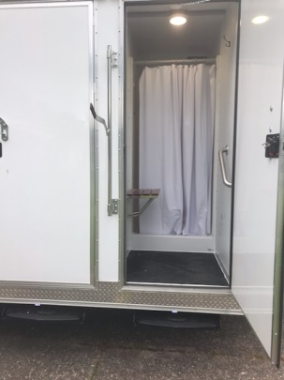

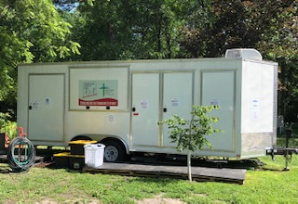

***To find out more of how you can become a KEY CONTRIBUTOR of ABMen USA national ministries to support our mission in Disaster Relief and our other national ministries, go to*** [***www.ABMen.org***](http://www.ABMen.org)

Greetings, Green Lake Volunteers!  I pray all is well and God is blessing you and yours.

I apologize for the somewhat late notice; however, it won’t be long before we are toiling together again at GLCC.  This year’s fall work party will take place September 8-14, 2019.  As in the past, check-in day will be Sunday and supper will be on your own.   As was the case in the Spring, **all participants will incur a partial cost for meals**; **lodging will continue to be provided at no cost**.  Meal cost information is contained on the attached registration form.  Please indicate to GLCC staff what would be your first meal and last meal; in the event you are not going to stay the entire week.

Don Rogers, ABMen District Representative (District 5), will again serve as our on-site coordinator for this working party.

I have attached a registration form for the fall work week, which you can fax, e-mail, or mail to GLCC.  You may also register by calling the GLCC at (920) 294-7230.  Please remember, registration is limited, so you should register at your earliest convenience.



Finally, if you have any additional questions prior to the work week, please feel free to contact me at the telephone number below or by e-mail.

In His Service,

Bill Morningstar

President, ABMen USA

[wmorningstar@suddenlinkmail.com](mailto:wmorningstar@suddenlinkmail.com)

(304) 549-6220

***“Striving to be the Hands and Feet of Christ”***

On October 5-19, 2019, I am leading another team to Puerto Rico to help Hurricane Maria victims get back into their homes. Join us for one or two weeks or something in between. The July Team made a house accessible for a handicapped man by widening the bathroom door and building a ramp. The house was also painted inside and out; the roof sealed; and new windows were installed.

Jack Cobb

American Baptist Men – USA

Disaster Relief Coordinator

[cobbjack@suddenlink.net](mailto:cobbjack@suddenlink.net)

(304) 206-8465 Cell

**Men’s Health News**

Attached: Checkup and Screening Guidelines for Men from Men’s Health Network. If you want more information, please contact Men’s Health Network at 202.543.MHN-1, or [www.menshealthnetwork.org](http://www.menshealthnetwork.org).

**These are the preventive care services for adult men as defined under the Patient**

**Protection and Affordability Care Act (PPACA):**

**Screenings:**

• - Blood pressure • - Type 2 Diabetes (for men with high blood pressure)

• - Prostate cancer (PSA) • - Cholesterol (for men age 35 and older)

• - HIV, sexually transmitted infection (STI) (for adults at higher risk)

• - Abdominal aortic aneurysm (one-time screening for men age 65 to 75 who have smoked)

• - Colorectal cancer including fecal occult blood testing, sigmoidoscopy or colonoscopy (for men age 50 to 75)

**Immunizations:**

• - Hepatitis A and B • - Herpes Zoster • - Human Papillomavirus • - Influenza

• - Measles, Mumps, Rubella • - Meningococcal • - Pneumococcal (pneumonia)

• - Tetanus, Diphtheria, Pertussis • - Varicella (Chicken Pox)

**Health Counseling:**

Doctors are encouraged to counsel patients about these health issues and refer them to appropriate resources as needed.

• - Healthy diet • - Weight loss • - Tobacco use • - Alcohol misuse

• - Depression • - Prevention of sexually transmitted infections (STI’s)

• - Use of aspirin to prevent cardiovascular disease

**You can find information about a specific health topic at these web sites:**

American Dental Association American Heart Association

312-440-2500 800-AHA-USA-1 (800-242-8721)

[www.ada.org](http://www.ada.org) www.heart.org

American Diabetes Association National Cancer Institute

800-DIABETES (800-342-2383) 800-422-6237

[www.diabetes.org](http://www.diabetes.org) [www.cancer.gov](http://www.cancer.gov)

National Institute of Mental Health Centers for Disease Control & Prevention

866-615-6464 800-CDC-INFO (800-232-4636)

[www.nimh.nih.gov](http://www.nimh.nih.gov) [www.cdc.gov](http://www.cdc.gov)

**Contributing Writers:**

Deacon Alvin Coleman Deacon Earle D. Clowney Brother Jack Cobb

Brother Tyno Carter Deacon Andrew Ladd

Sister Leslie George Brother Bill Morningstar

Editor: Brother Vernon A. Clement

Assistant Editor/Proofreader: Dr. Earle D. Clowney